Group members

Christopher Slaghuis - 31713858

Jean Marx - 32313845

User manual

CMPG Group Project 2020

# Table of Contents

Contents

Table of Contents 1

Software & Hardware Requirements 2

Supported operating systems: 2

Hardware requirements 2

Getting started 3

Initial setup 3

Opportunities for Future Expansion 3

WhatsApp Functionality 3

Slip Functionality 3

Database Schema 4

Methods 4

Time Journal 5

Table of Figures 7

# Software & Hardware Requirements

## Supported operating systems:

Windows 10 version 1703 or higher: Home, Professional, Education, and Enterprise (LTSC and S are not supported)

Windows Server 2019: Standard and Datacenter

Windows Server 2016: Standard and Datacenter

Windows 8.1 Core, Professional, and Enterprise

Windows Server 2012 R2: Essentials, Standard, Datacenter

Windows 7 SP1: Home Premium, Professional, Enterprise, Ultimate

(64 bit recommended)

## Hardware requirements

1.8 GHz or faster processor. Quad-core or better recommended

2 GB of RAM;

Hard disk space: Minimum of 800MB

SSD recommended, or 7200rpm harddrive

Video card that supports a minimum display resolution of 720p (1280 x 720)

# Getting started

## Initial setup

This program, in it’s initial installation phase, will be installed on POS PC’s at the *Take One* movie theatre to simplify and manage ticket sales as well as maintaining the cinemas and movies.

Our team will handle the on-site installation of the system and keep our eye on the system for a few months after implementation in case technical help is required.

## Opportunities for Future Expansion

### WhatsApp Functionality

We wish to incorporate a WhatsApp functionality into our system at some point in the future that will send the client’s booking details directly to their phone, as well as a reminder a few minutes before the show starts so that the customers can start taking their seats. The functionality will include a QR code with the details of the booking.

### Slip Functionality

Due to COVID-19 we did not have access to additional hardware as we were all working from home, so therefore once *physical* installation is possible, we plan on implementing a receipt feature for physical copies of the bookings.

# Database Schema

# Methods

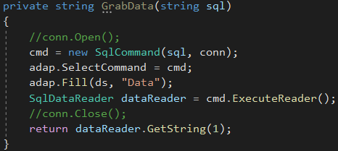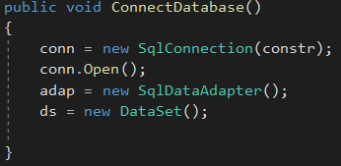

Figure - Connect to DB Method

Figure - Read Method

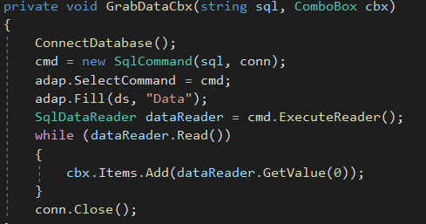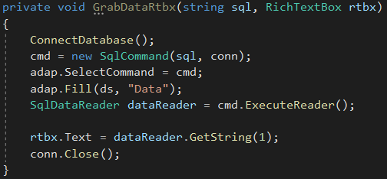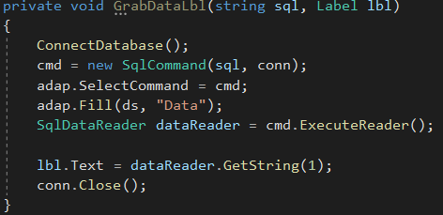

Figure - Read to ComboBox Method

Figure - Read to RichTextBox Method

Figure - Read to Label Method

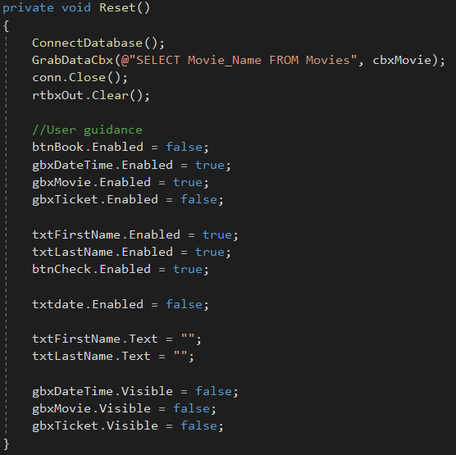

Figure - Reset Book Form

# Time Journal

Our team had some technical issues and had to reupload to a new repository on the 25th. Data from GitHub may not be 100% accurate.

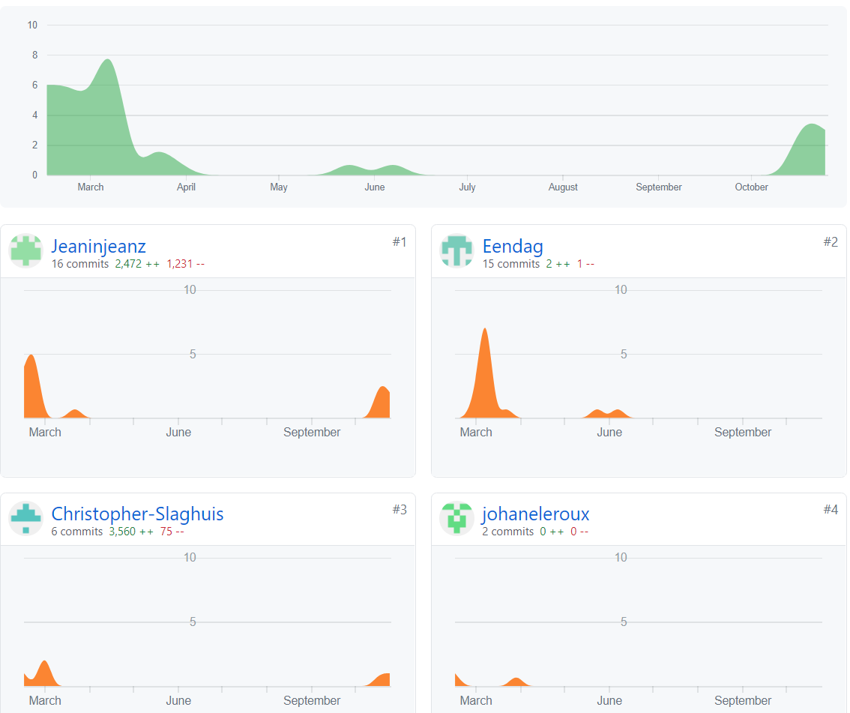Please note Eendag (James Uys) and johaneleroux were members of our initial group.

Figure 7 - GitHub Contributions - First Repository

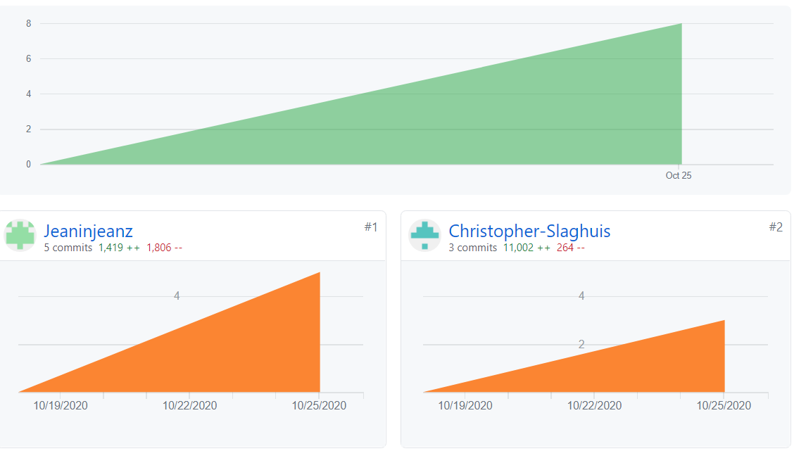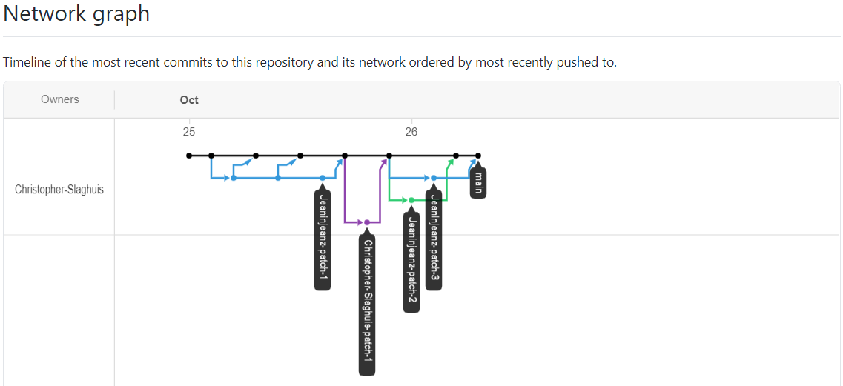

Figure 8 - GitHub Contributions - Second Repository

Figure 9 - Network Graph - Second Repository

# Table of Figures

Figure 1- Connect to DB Method 4

Figure 2 - Read Method 4

Figure 3 - Read to ComboBox Method 5

Figure 4 - Read to RichTextBox Method 5

Figure 5 - Read to Label Method 5

Figure 6 - Reset Book Form 6

Figure 7 - GitHub Contributions - First Repository 7

Figure 8 - GitHub Contributions - Second Repository 8

Figure 9 - Network Graph - Second Repository 8